**Sustainable cultivation**   
To offer the best quality flowers and plants, growers protect their crops against diseases and pests. They are increasingly focussing on greenery solutions. Leading Dutch growers have the ambition to use virtually no non-organic means by 2030. Figures from CBS Statistics Netherlands show that 90% of flower growers already use biological pest control agents such as predatory mites, parasitic wasps, hoverflies, fungi and other natural methods to keep diseases and pests under control. The floriculture sector is thus successfully focusing on innovation and sustainability.

**Decrease in use of crop protection**  
Over the past five years, there has been a sharp decline in the use of environmentally harmful crop protection products by growers in Europe and Africa. This is evident from figures from MPS, the certification organisation that focuses on making the sector sustainable through transparency and measurability (source MPS).

**Strict European guidelines for flowers**  
In addition to innovations, strict European guidelines ensure that both domestic and imported flowers meet high sustainability standards. Crop protection products and their active ingredients are assessed for safety to humans, animals and the environment. First at the European level, and upon approval, the member states - in the Netherlands the Ctgb (Board for the Authorisation of Crop Protection Agents and Biocides) - assess the end product and decide whether or not to authorise it. The European Commission only approves an active substance after a thorough and comprehensive scientific assessment to ensure that the substance is safe for use. Data on approved substances and authorised agents are generally reviewed every ten years based on the latest scientific insights. Different pests and diseases occur in Africa than in Europe. The climate conditions are also completely different. Crop protection there requires different active substances or different compositions.

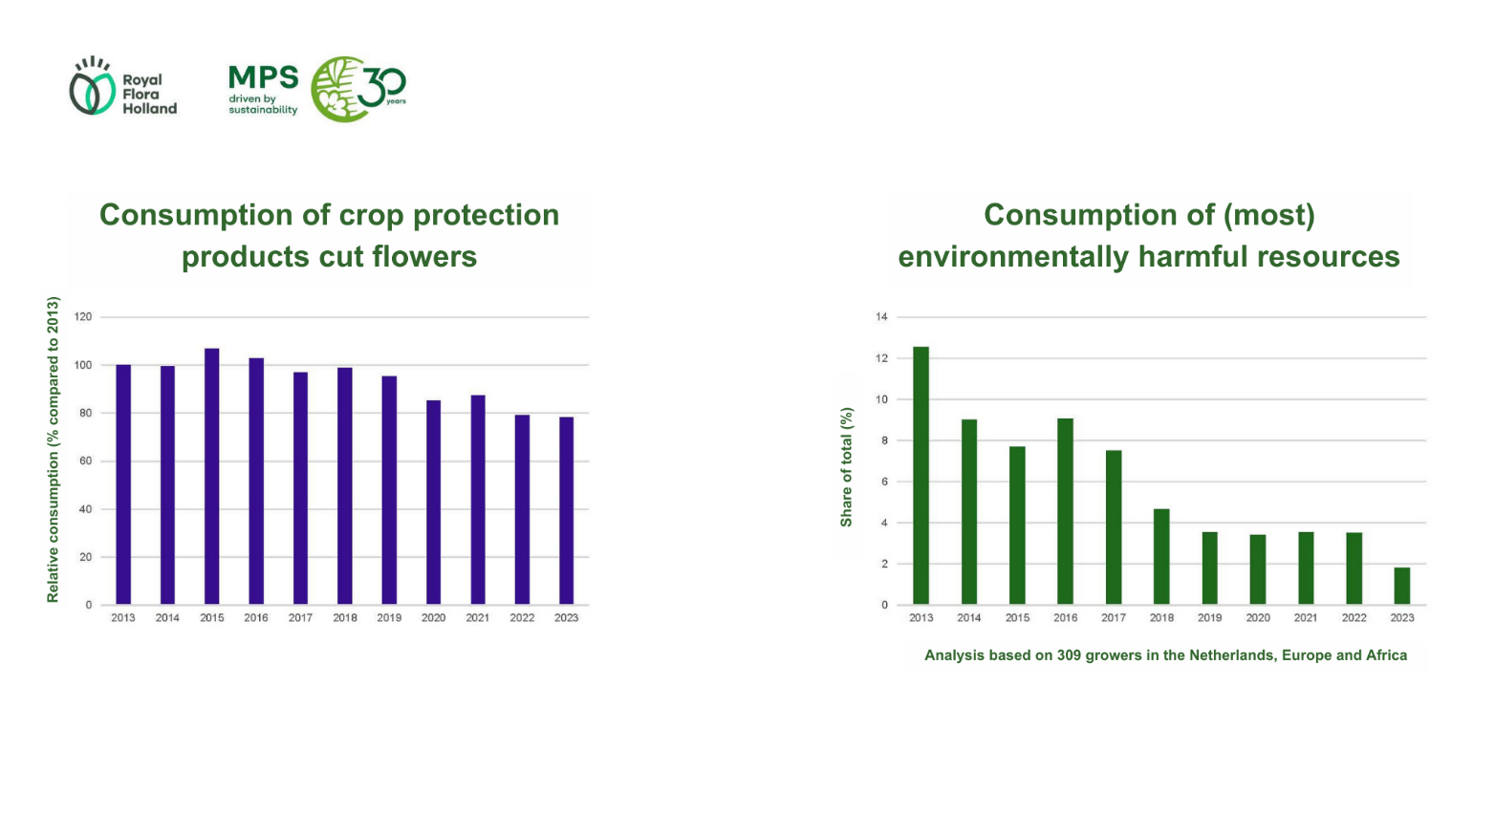In addition to the joint international efforts to reduce chemical crop protection, strict guidelines for the import of flowers apply in Europe. Every flower in the shop complies with these rules. Consumers can enjoy a beautiful bouquet with peace of mind.